3
Database Connection

Review and Preview

At this point, we have looked at databases and how they are structured. We have seen that data objects work between the database and the Visual C# ‘front-end’ to manage the database.

In this chapter, for the first time, we use Visual C# to connect to a database. This connection is made with the data objects we have been referring to. Using data bound controls, in conjunction with the data objects, will allow us to view information in the database.

Data Object Overview

Visual C# provides several objects that allow interaction with databases. These objects fall in one of five categories:

- Connections allow a program to connect to a database
- Data containers hold data after it has been loaded from a database.
- Data adapters move data between databases and containers
- Command objects allow manipulation of the data
- Navigation objects allow a user to move through (and also modify) data

Some objects (data containers, data adapters, navigation objects) are generic in nature and work with any type of database.

Connection objects and command objects are specific to the type of database being used. Visual C# provides objects that work with Object Linking and Embedding Databases (OLE DB), SQL Server, including the Microsoft Data Engine (MSDE), Open Database Connectivity (ODBC) and Oracle databases. Don’t worry if you don’t understand all this, right now. In these notes, we will work with Access databases (OLE DB) and SQL Server databases. In the final chapter, we’ll look at connecting to other databases.

We will look at each data object in detail. As we progress through our discussion of these objects, we will gradually open and view items from the books database using Visual C#.
Connection Object

The connection object establishes a connection between your application and the database.

Connection
VC#
Application
Database

As mentioned, Visual C# supports several databases types. Hence, it offers several different connection objects: OleDbConnection, SqlConnection, OdbcConnection, OracleConnection.

Connection object properties:

ConnectionString Contains the information used to establish a connection to a database.
Database Name of the current database.
DataSource Name of the current database file.
State Current connection state (Closed, Connecting, Open, Executing, Fetching, Broken)

Connection object methods:

Open Open the connection.
Close Close the connection.
Dispose Dispose of the connection object.

Connection Object - Access Database

To use the OleDbConnection object and other OLE database objects, an application must have this line at the top of the corresponding code listing:

using System.Data.OleDb;

Every Access example we build in this class will have this line.

To declare and construct an OleDbConnection object named myConnection, using a ConnectionString named myConnectionString, use:

OleDbConnection myConnection;
myConnection = new OleDbConnection(myConnectionString);

The ConnectionString for an Access database is the following string:

Provider=Microsoft.ACE.OLEDB.12.0; Data Source = DatabaseName

where DatabaseName is a complete path to the database.

We’re about to start looking at the books database (BooksDB.accdb) discussed in Chapter 2. This database is found in the VCSDB\Databases directory. Make a copy of the database and place it in a working directory (you decide on a name – we will use VCSDB\Working). We do this to insure there is always a valid copy of BooksDB.accdb on your computer. You will see that the power of the Visual C# opens up the possibility of doing damage to a database (we, of course, will try to minimize this possibility). So, we are just living by the adage, “Better safe, than sorry.”

Access Databases and 64-Bit Operating Systems

The Access databases used in these notes only work with 32-bit operating systems. If you are using a 64-bit version of Visual Studio, you need to make one change to each project you build.

Follow these steps:

- Once your project is built, choose the Project menu item, and select your project’s Properties entry.
- In the window that appears, choose the Compile tab.
- Under Target CPU, make sure the selection is x86, not AnyCPU. The changed window should look like this:

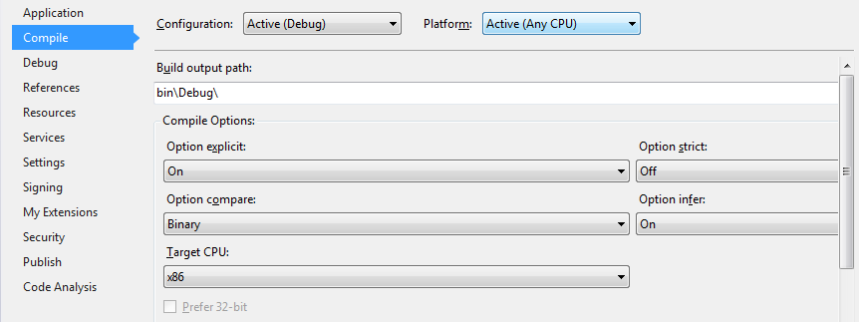

- Close the window to finalize the change.

How will you know if you have an operating system problem? The first symptom is that your application will have no data displayed, indicating the database did not open correctly. Secondly, the Immediate Window will have this error message:

An unhandled exception of type 'System.InvalidOperationException' occurred in System.Data.dll

Or, when opening the database, you may see this window:

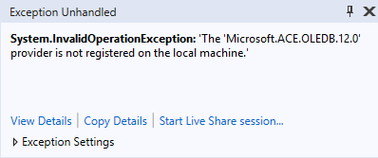

If you see such symptoms, make the above note correction to your project’s properties.

Connection Object - SQL Server Database

To use the SqlConnection object, an application must have this line at the top of the corresponding code listing:

using System.Data.SqlClient;

Every SQL Server example we build in this class should have this line.

To declare and construct an SqlConnection object named myConnection, using a ConnectionString named myConnectionString, use:

SqlConnection myConnection;
myConnection = new SqlConnection(myConnectionString);

The ConnectionString for an SQL Server database is the following string:

Data Source=SQLInstanceName; AttachDbFilename=DatabaseName; Integrated Security=True; Connect Timeout=30; User Instance=True

where SQLInstanceName is the name of your SQL Server instance (set when installed; if using default SQL Server Express settings, name is .\SQLEXPRESS) and DatabaseName is a complete path to the database.

We’re about to start looking at the books database (SQLBooksDB.mdf), SQL Server version of BooksDB.accdb). Make a copy of the database and place it in a working directory (you decide on a name – we will use VBDB\Working).

Example 3-1

Accessing the Books Database

After copying the database (BooksDB.accdb or SQLBooksDB.mdf) to your working directory, start a new application. Our end goal with this application is to develop a form where we can look through the Titles table in the books database. We start by simply opening the database using a connection object.

- Place a single label control on the form.

- Set the following properties:

Form1:
Name frmTitles
FormBorderStyle FixedSingle
StartPosition CenterScreen
Text Titles Database

label1:
Name lblState
AutoSize True
BackColor White
BorderStyle Fixed3D
Text [blank]

When done, the form will look something like this:

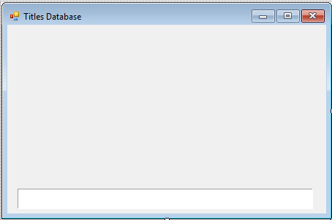

All the extra space will be used as we continue building this application.

- Open the code window and add this line at the top:

Access Database:

using System.Data.OleDb;

SQL Server Database:

using System.Data.SqlClient;

- Use this form level declaration to declare the connection:

Access Database:

OleDbConnection booksConnection;

SQL Server Database:

SqlConnection booksConnection;

- Add this code to the frmTitles Load method:

Access Database:

private void FrmTitles_Load(object sender, EventArgs e)
{
// connect to books database
booksConnection = new OleDbConnection("Provider=Microsoft.ACE.OLEDB.12.0; Data Source = c:\\VCSDB\\Working\\BooksDB.accdb");
//open the connection
booksConnection.Open();
//display state
lblState.Text = booksConnection.State.ToString();
//close the connection
booksConnection.Close();
//display state
lblState.Text += booksConnection.State.ToString();
//dispose of the connection object
booksConnection.Dispose();
}

SQL Server Database:

private void FrmTitles_Load(object sender, EventArgs e)
{
// connect to books database
booksConnection = new SqlConnection("Data Source=.\\SQLEXPRESS; AttachDbFilename=c:\\VCSDB\\Working\\SQLBooksDB.mdf; Integrated Security=True; Connect Timeout=30; User Instance=True");
//open the connection
booksConnection.Open();
//display state
lblState.Text = booksConnection.State.ToString();
//close the connection
booksConnection.Close();
//display state
lblState.Text += booksConnection.State.ToString();
//dispose of the connection object
booksConnection.Dispose();
}

In this code we construct the connection using the proper connection string. Notice the connection string assumes the database is in the c:\VCSDB\Working folder. You will have to change this if your working copy of the database is located elsewhere. Then, we simply open, close and dispose of the connection. The status is displayed in the lblState control.

The Access Database finished code should be (lines added are shaded):

using System;
using System.Collections.Generic;
using System.ComponentModel;
using System.Data;
using System.Drawing;
using System.Text;
using System.Windows.Forms;
using System.Data.OleDb;
namespace Example_3_1
{
public partial class frmTitles : Form
{
public frmTitles()
{
InitializeComponent();
}
OleDbConnection booksConnection;
private void FrmTitles_Load(object sender, EventArgs e)
{
// connect to books database
booksConnection = new OleDbConnection("Provider=Microsoft.ACE.OLEDB.12.0; Data Source = c:\\VCSDB\\Working\\BooksDB.accdb");
//open the connection
booksConnection.Open();
//display state
lblState.Text = booksConnection.State.ToString();
//close the connection
booksConnection.Close();
//display state
lblState.Text += booksConnection.State.ToString();
//dispose of the connection object
booksConnection.Dispose();
}
}
}
The SQL Server Database finished code should be (lines added are shaded):

using System;
using System.Collections.Generic;
using System.ComponentModel;
using System.Data;
using System.Drawing;
using System.Text;
using System.Windows.Forms;
using System.Data.SqlClient;
namespace Example_3_1
{
public partial class frmTitles : Form
{
public frmTitles()
{
InitializeComponent();
}
SqlConnection booksConnection;
private void FrmTitles_Load(object sender, EventArgs e)
{
// connect to books database
booksConnection = new SqlConnection("Data Source=.\\SQLEXPRESS; AttachDbFilename=c:\\VCSDB\\Working\\SQLBooksDB.mdf; Integrated Security=True; Connect Timeout=30; User Instance=True");
//open the connection
booksConnection.Open();
//display state
lblState.Text = booksConnection.State.ToString();
//close the connection
booksConnection.Close();
//display state
lblState.Text += booksConnection.State.ToString();
//dispose of the connection object
booksConnection.Dispose();
}
}
}
- Save the application. Run the application. You should see:

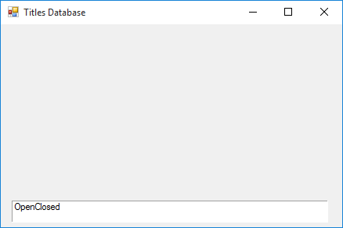

This shows that the connection was opened and then closed. If you do not see this or you get an error message, make sure your connection string is correct and the books database is really located where you (and your connection string) thinks it is.

If you get an error message similar to this

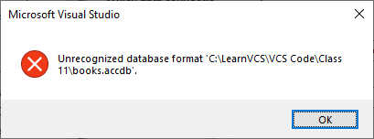

This indicates you are missing the proper driver for the Access Database. See the proper download instructions in Class 2.

Command Object

The command object is used to define commands to send to the database. In this course, these commands will be SQL queries. We’ll learn SQL in Chapter 4. For now, we’ll just give you any queries you may need.

Command objects are used by data adapter objects (discussed next) to create datasets which hold data tables (discussed after data adapters). The information in these tables can then be viewed in a Visual C# application:

DataAdapter
(CommandObject)

Connection
VC#
Application
Database
DataSet
DataTables

Command Object – Access Database

To declare and construct an OleDbCommand object named myCommand using a SQL query named myQuery for a connection object named myConnection, use:

OleDbCommand myCommand;
myCommand = new OleDbCommand(myQuery, myConnection)

After a quick example, we see how to use such an object with a data adapter to create a data table.

Command Object – SQL Server Database

To declare and construct an SqlCommand object named myCommand using a SQL query named myQuery for a connection object named myConnection, use:

SqlCommand myCommand;
myCommand = new SqlCommand(myQuery, myConnection)

After a quick example, we see how to use such an object with a data adapter to create a data table.

Example 3-1 (Command Object)

Accessing the Books Database

We add a command object to our example. We need a SQL query to retrieve data from the Titles table of the books database. The query that does this is:

Select * From Titles

This says select all fields (* is a wildcard) from the Titles table.

- Add this form level declaration:

Access Database:

OleDbCommand titlesCommand;

SQL Server Database:

SqlCommand titlesCommand;

- Add the shaded code to the frmTitles Load method:

Access Database:

private void FrmTitles_Load(object sender, EventArgs e)
{
// connect to books database
booksConnection = new OleDbConnection("Provider=Microsoft.ACE.OLEDB.12.0; Data Source = c:\\VCSDB\\Working\\BooksDB.accdb");
//open the connection
booksConnection.Open();
//display state
lblState.Text = booksConnection.State.ToString();
// establish command object
titlesCommand = new OleDbCommand("Select * from Titles", booksConnection);
//close the connection
booksConnection.Close();
//display state
lblState.Text += booksConnection.State.ToString();
//dispose of the connection object
booksConnection.Dispose();
titlesCommand.Dispose();
}
SQL Server Database:

private void FrmTitles_Load(object sender, EventArgs e)
{
// connect to books database
booksConnection = new SqlConnection("Data Source=.\\SQLEXPRESS; AttachDbFilename=c:\\VCSDB\\Working\\SQLBooksDB.mdf; Integrated Security=True; Connect Timeout=30; User Instance=True");
//open the connection
booksConnection.Open();
//display state
lblState.Text = booksConnection.State.ToString();
// establish command object
titlesCommand = new SqlCommand("Select * from Titles", booksConnection);
//close the connection
booksConnection.Close();
//display state
lblState.Text += booksConnection.State.ToString();
//dispose of the connection object
booksConnection.Dispose();
titlesCommand.Dispose();
}

This code creates the command object for the books connection object.

- Resave and rerun the application, making sure you get no errors.
DataAdapter Object

As just seen, a data adapter object uses a command object to transfer data between a connection object and a dataset containing one or more data table(s). For our initial work, we will use a data adapter to directly form a data table (discussed next), without using a dataset. In general, you need one data adapter object for each table of data you want to view.

Data adapter properties:

DeleteCommand Command object that allows the adapter to delete rows from a data table.
InsertCommand Command object that allows the adapter to insert rows into a data table.
SelectCommand Command object that the adapter uses to select rows for a data table.
UpdateCommand Command object that the adapter uses to update rows in a data table.

Data adapter methods:

Fill Fills the data adapter with a given data table.
Update Updates the data table held by the data adapter.

DataAdapter Object – Access Database

To declare and construct an OleDbDataAdapter named myAdapter, use:

OleDbDataAdapter myAdapter;
myAdapter = new OleDbDataAdapter();

We specify the SelectCommand (myCommand, a command object) with a SQL query to select the rows that will make up the corresponding data table.

myAdapter.SelectCommand = myCommand;

Once the SelectCommand is specified, the other command objects (DeleteCommand, InsertCommand, UpdateCommand) are built using a command builder object. The statement that accomplishes this task for our example adapter (myAdapter) is:

OleDbCommandBuilder myCommandBuilder = new OleDbCommandBuilder(myAdapter);

Once this line is executed, the three command objects can be viewed (if desired) by examining:

myCommandBuilder.GetDeleteCommand.CommandText
myCommandBuilder.GetInsertCommand.CommandText
myCommandBuilder.GetUpdateCommand.CommandText

We really don’t ever look at these command objects – they are used by the Update method of the data adapter. We look at that method in Chapter 5 when we start our study of database management tasks.

Believe it or not, we’re getting close to seeing some actual data! The data adapter’s Fill method accomplishes this task, but first we need to look at datasets and data tables.
DataAdapter Object – SQL Server Database

To declare and construct an SqlDataAdapter named myAdapter, use:

SqlDataAdapter myAdapter;
myAdapter = new SqlDataAdapter();

We specify the SelectCommand (myCommand, a command object) with a SQL query to select the rows that will make up the corresponding data table.

myAdapter.SelectCommand = myCommand;

Once the SelectCommand is specified, the other command objects (DeleteCommand, InsertCommand, UpdateCommand) are built using a command builder object. The statement that accomplishes this task for our example adapter (MyAdapter) is:

SqlCommandBuilder myCommandBuilder = new SqlCommandBuilder(myAdapter);

Once this line is executed, the three command objects can be viewed (if desired) by examining:

myCommandBuilder.GetDeleteCommand.CommandText
myCommandBuilder.GetInsertCommand.CommandText
myCommandBuilder.GetUpdateCommand.CommandText

We really don’t ever look at these command objects – they are used by the Update method of the data adapter. We look at that method in Chapter 5 when we start our study of database management tasks.

Believe it or not, we’re getting close to seeing some actual data! The data adapter’s Fill method accomplishes this task, but first we need to look at datasets and data tables.
DataSet Object

A dataset object provides all the features you need to build, load, store, manipulate and save data in a relational database. It is a ‘container’ for multiple data table objects.

Dataset properties:

DataSetName Name assigned to dataset.
Tables A collection of data tables stored in the dataset.

To declare and construct a DataSet named myDataSet, use:

DataSet myDataSet;
myDataSet = new DataSet()

To add a data table (myTable) to a dataset, use:

myDataSet.Tables.Add(myTable);

We don’t use data set objects a lot in this course. We prefer to work directly with data tables.
DataTable Object

A data table object represents the data contained in one table of a dataset object.

Data table properties:

Columns Collection of DataColumn objects that define information in the columns of the table.
DataSet The DataSet object (if any) that contains this DataTable.
DefaultView A DataView representing the DataTable contents.
Rows Collection of DataRow objects that define each table row.
TableName Name of data table.

Data table methods:

Clear Removes all rows from data table.
Copy Makes a copy of the data table.
ImportRow Copies a DataRow object into the data table.
NewRow Creates a new DataRow object for the data table.

To declare and construct a data table named myTable, use:

DataTable myTable;
myTable = new DataTable();

Once the table is created, it is filled with data using the Fill method for a corresponding data adapter control. If that adapter is myAdapter, the syntax is:

myAdapter.Fill(myTable);

At this point, we have a data table (formed using by sending a SQL query to the database) we can view in a Visual C# application.
DataRow Object

A data row object represents the information in one record of a data table. It is very useful for retrieving and/or modifying individual fields in a record.

Data row properties:

Item Gets or sets one of the row’s fields. The parameter can be the column index or the field name.
Table Reference to data table containing the row.

Data row methods:

BeginEdit Puts data row in edit mode.
CancelEdit Cancels the current edit on the data row.
Delete Deletes the row from the data table.

We will look at data rows in more detail later in the course, especially in the example projects in Chapter 10.
Example 3-1 (Data Table)

Accessing the Books Database

We add a data adapter object and a data table object to our example. The data table associated with the data adapter will have the Titles table from the books database.

- Add these form level declarations:

Access Database:

OleDbDataAdapter titlesAdapter;
DataTable titlesTable;

SQL Server Database:

SqlDataAdapter titlesAdapter;
DataTable titlesTable;

- Add the shaded code to the frmTitles Load method:

Access Database:

private void FrmTitles_Load(object sender, EventArgs e)
{
// connect to books database
booksConnection = new OleDbConnection("Provider=Microsoft.ACE.OLEDB.12.0; Data Source = c:\\VCSDB\\Working\\BooksDB.accdb");
//open the connection
booksConnection.Open();
//display state
lblState.Text = booksConnection.State.ToString();
// establish command object
titlesCommand = new OleDbCommand("Select * from Titles", booksConnection);
// establish data adapter/data table
titlesAdapter = new OleDbDataAdapter();
titlesAdapter.SelectCommand = titlesCommand;
titlesTable = new DataTable();
titlesAdapter.Fill(titlesTable);
//close the connection
booksConnection.Close();
//display state
lblState.Text += booksConnection.State.ToString();
//dispose of the connection object
booksConnection.Dispose();
titlesCommand.Dispose();
titlesAdapter.Dispose();
titlesTable.Dispose();
}

SQL Server Database:

private void FrmTitles_Load(object sender, EventArgs e)
{
// connect to books database
booksConnection = new SqlConnection("Data Source=.\\SQLEXPRESS; AttachDbFilename=c:\\VCSDB\\Working\\SQLBooksDB.mdf; Integrated Security=True; Connect Timeout=30; User Instance=True");
//open the connection
booksConnection.Open();
//display state
lblState.Text = booksConnection.State.ToString();
// establish command object
titlesCommand = new SqlCommand("Select * from Titles", booksConnection);
// establish data adapter/data table
titlesAdapter = new SqlDataAdapter();
titlesAdapter.SelectCommand = titlesCommand;
titlesTable = new DataTable();
titlesAdapter.Fill(titlesTable);
//close the connection
booksConnection.Close();
//display state
lblState.Text += booksConnection.State.ToString();
//dispose of the connection object
booksConnection.Dispose();
titlesCommand.Dispose();
titlesAdapter.Dispose();
titlesTable.Dispose();
}

This new code creates the data adapter and loads it with data from the Titles table.

- Resave and rerun the application. Again, make sure there are no errors. If no errors occur, you have successfully created a data table. Next, we look at how to view information from this table in a Visual C# application.

Data Bound Controls

We have seen that the ADO .NET data objects allow us to connect to a database and form a data table. Yet, these objects do not provide us with any way to view the information in a database. To view the information, we use data bound controls that are special controls with properties established by database fields. A data bound control is needed for each field (column) in the database table you need to view. Most of the standard Visual C# tools can be used as data bound controls.

Data Bound Control
DataAdapter
(CommandObject)

Connection
VC#
Application
Database
DataTable

Some data bound data controls (using simple binding) are:

Label Can be used to provide display-only access to a specified text data field. The label Text property is usually bound.
Text Box Can be used to provide read/write access to a specified text data field. Probably, the most widely used data bound tool. Text property is usually bound.
Check Box Used to provide read/write access to a Boolean field. Value property is data bound.
Picture Box Used to display a graphical image from a bitmap, icon, gif, jpeg, or metafile file. Provides read/write access to a image/binary data field. Image property is data bound.
Other controls using complex binding (look at in further detail later in this course):

List Box Can be used to display all values of a particular field in a database.
Combo Box Can be used to display all values of a particular field in a database.
Data Grid View Can be used to display an entire database table.

To bind a particular property (myProperty) of a control (myControl) to a particular field (myField) of a data table object (myTable), the syntax is:

myControl.DataBindings.Add(myProperty, myTable, myField);

So, every control that is to be bound to a database field needs a statement like this. The bindings are usually done in the initial form’s Load method.

To clear a previously defined data binding, the syntax is:

myControl.DataBindings.Clear();

Example 3-1 (Data Binding)

Accessing the Books Database

We now add some controls that are bound to fields in the Titles database table so we can view some data.

- Remove the label control used to display state (we know things are working okay by now).

- Add four label controls and four text box controls, so the form looks like this:

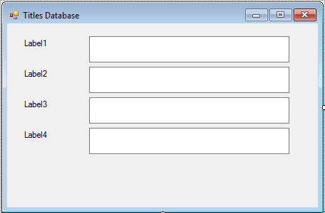

- Set the following properties:

Label1:
Text Title

Label2:
Text Year Published

Label3:
Text ISBN

Label4:
Text Publisher ID
TextBox1:
Name txtTitle
BackColor White
ReadOnly True
MultiLine True

TextBox2:
Name txtYearPublished
BackColor White
ReadOnly True
MultiLine True

TextBox3:
Name txtISBN
BackColor White
ReadOnly True
MultiLine True

TextBox4:
Name txtPubID
BackColor White
ReadOnly True
MultiLine True

The finished form should appear as:

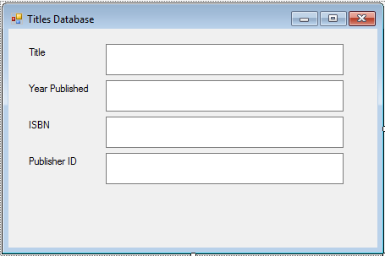

- Add the shaded lines to the frmTitles Load method. These lines bind the four text boxes to their respective fields in the Titles table. Remove the lines referring to lblState (we removed that control).

Access Database:

private void FrmTitles_Load(object sender, EventArgs e)
{
// connect to books database
booksConnection = new OleDbConnection("Provider=Microsoft.ACE.OLEDB.12.0; Data Source = c:\\VCSDB\\Working\\BooksDB.accdb");
//open the connection
booksConnection.Open();
// establish command object
titlesCommand = new OleDbCommand("Select * from Titles", booksConnection);
// establish data adapter/data table
titlesAdapter = new OleDbDataAdapter();
titlesAdapter.SelectCommand = titlesCommand;
titlesTable = new DataTable();
titlesAdapter.Fill(titlesTable);
// bind controls to data table
txtTitle.DataBindings.Add("Text", titlesTable, "Title");
txtYearPublished.DataBindings.Add("Text", titlesTable, "Year_Published");
txtISBN.DataBindings.Add("Text", titlesTable, "ISBN");
txtPubID.DataBindings.Add("Text",titlesTable, "PubID");
//close the connection
booksConnection.Close();
//dispose of the connection object
booksConnection.Dispose();
titlesCommand.Dispose();
titlesAdapter.Dispose();
titlesTable.Dispose();
}

SQL Server Database:

private void FrmTitles_Load(object sender, EventArgs e)
{
// connect to books database
booksConnection = new SqlConnection("Data Source=.\\SQLEXPRESS; AttachDbFilename=c:\\VCSDB\\Working\\SQLBooksDB.mdf; Integrated Security=True; Connect Timeout=30; User Instance=True");
//open the connection
booksConnection.Open();
//display state
lblState.Text = booksConnection.State.ToString();
// establish command object
titlesCommand = new SqlCommand("Select * from Titles", booksConnection);
// establish data adapter/data table
titlesAdapter = new SqlDataAdapter();
titlesAdapter.SelectCommand = titlesCommand;
titlesTable = new DataTable();
titlesAdapter.Fill(titlesTable);
// bind controls to data table
txtTitle.DataBindings.Add("Text", titlesTable, "Title");
txtYearPublished.DataBindings.Add("Text", titlesTable, "Year_Published");
txtISBN.DataBindings.Add("Text", titlesTable, "ISBN");
txtPubID.DataBindings.Add("Text",titlesTable, "PubID");
//close the connection
booksConnection.Close();
//display state
lblState.Text += booksConnection.State.ToString();
//dispose of the connection object
booksConnection.Dispose();
titlesCommand.Dispose();
titlesAdapter.Dispose();
titlesTable.Dispose();
}

- Resave and rerun the application. You should see:

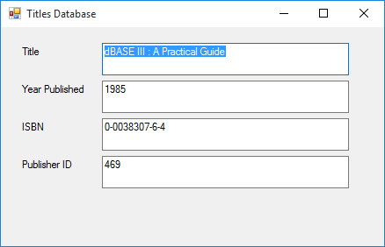

At long last, we see some data in our Visual C# application. The first record in the Titles table is being displayed. We still have no way of navigating through the table. We add that capability next with a very powerful data object, the CurrencyManager object.
CurrencyManager Object

A final component we need to view data is a currency manager object. Once associated with a data table object, the currency manager not only allows navigation through the rows of the table, but also provides several database management tasks such as editing, adding record and deleting records.

Currency
Manager
Data Bound Control
DataAdapter
(CommandObject)

Connection
VC# Application
Database
DataTable

Currency manager object properties:

Bindings Collection of controls bound to this manager.
Count Number of rows in table associated with manager.
Position Gets or sets the current row in the data table (ranges from 0 to Count – 1).

Currency manager methods:

AddNew Add a new row to the data source.
CancelCurrentEdit Cancels the current editing operation.
EndCurrentEdit Ends the current editing operation, accepting any changes.
Refresh Refreshes the bound controls.
RemoveAt Removes the indicated data row.

For now, we look specifically at the navigational abilities of the currency manager object. First, declare a currency manager object (myManager) using:

CurrencyManager myManager;

We use the BindingContext of the associated data table to establish a reference for the currency manager. For a table named myTable, we use this syntax:

myManager = (CurrencyManager) this.BindingContext[myTable];

This simply converts the binding context information of the table into a currency manager object.

Once the currency manager object is established, basic navigation among the Count rows in the data table is accomplished via a simple modification of the Position property. Look at the final incarnation of Example 3-1 to see its use in such a manner.
Example 3-1 (Final Version)

Accessing the Books Database

Lastly, we add some controls that allow navigation through the rows of the Titles database table

- Add four button controls so the form looks like this:

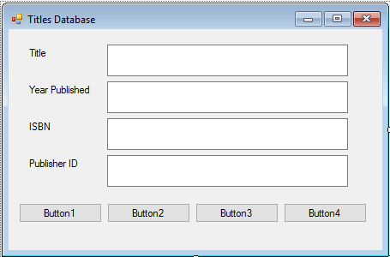

- Set the following properties:

Button1:
Name btnFirst
Text &First

Button2:
Name btnPrevious
Text &Previous

Button3:
Name btnNext
Text &Next

Button4:
Name btnLast
Text &Last
The finished form is:

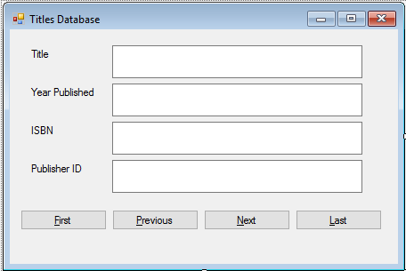

- Add this form level declaration:

CurrencyManager titlesManager;

- Add the shaded lines to the frmTitles Load method. These lines set up the currency manager reference to the Titles table.

Access Database:

private void FrmTitles_Load(object sender, EventArgs e)
{
// connect to books database
booksConnection = new OleDbConnection("Provider=Microsoft.ACE.OLEDB.12.0; Data Source = c:\\VCSDB\\Working\\BooksDB.accdb");
//open the connection
booksConnection.Open();
// establish command object
titlesCommand = new OleDbCommand("Select * from Titles", booksConnection);
// establish data adapter/data table
titlesAdapter = new OleDbDataAdapter();
titlesAdapter.SelectCommand = titlesCommand;
titlesTable = new DataTable();
titlesAdapter.Fill(titlesTable);
// bind controls to data table
txtTitle.DataBindings.Add("Text", titlesTable, "Title");
txtYearPublished.DataBindings.Add("Text", titlesTable, "Year_Published");
txtISBN.DataBindings.Add("Text", titlesTable, "ISBN");
txtPubID.DataBindings.Add("Text",titlesTable, "PubID");
// establish currency manager
titlesManager = (CurrencyManager) BindingContext[titlesTable];
//close the connection
booksConnection.Close();
//dispose of the connection object
booksConnection.Dispose();
titlesCommand.Dispose();
titlesAdapter.Dispose();
titlesTable.Dispose();
}
SQL Server Database:

private void FrmTitles_Load(object sender, EventArgs e)
{
// connect to books database
booksConnection = new SqlConnection("Data Source=.\\SQLEXPRESS; AttachDbFilename=c:\\VCSDB\\Working\\SQLBooksDB.mdf; Integrated Security=True; Connect Timeout=30; User Instance=True");
//open the connection
booksConnection.Open();
//display state
lblState.Text = booksConnection.State.ToString();
// establish command object
titlesCommand = new SqlCommand("Select * from Titles", booksConnection);
// establish data adapter/data table
titlesAdapter = new SqlDataAdapter();
titlesAdapter.SelectCommand = titlesCommand;
titlesTable = new DataTable();
titlesAdapter.Fill(titlesTable);
// bind controls to data table
txtTitle.DataBindings.Add("Text", titlesTable, "Title");
txtYearPublished.DataBindings.Add("Text", titlesTable, "Year_Published");
txtISBN.DataBindings.Add("Text", titlesTable, "ISBN");
txtPubID.DataBindings.Add("Text",titlesTable, "PubID");
// establish currency manager
titlesManager = (CurrencyManager) BindingContext[titlesTable];
//close the connection
booksConnection.Close();
//display state
lblState.Text += booksConnection.State.ToString();
//dispose of the connection object
booksConnection.Dispose();
titlesCommand.Dispose();
titlesAdapter.Dispose();
titlesTable.Dispose();
}

- Add these four Click methods for the navigation buttons; each method simply modifies the Position property accordingly:

private void BtnFirst_Click(object sender, EventArgs e)
{
titlesManager.Position = 0;
}

private void BtnPrevious_Click(object sender, EventArgs e)
{
titlesManager.Position--;
}

private void BtnNext_Click(object sender, EventArgs e)
{
titlesManager.Position++;
}

private void BtnLast_Click(object sender, EventArgs e)
{
titlesManager.Position = titlesManager.Count - 1;
}

- Save the application one last time (Access version saved in the Example 3-1 folder in VCSDB\Code\Class 3 folder; SQL Server version saved in the Example 3-1 SQL folder in VCSDB\Code\Class 3 folder). Run the application. Try out the navigation buttons. Notice how all the fields update with each click of a button. Here’s the second record (I clicked Next once).

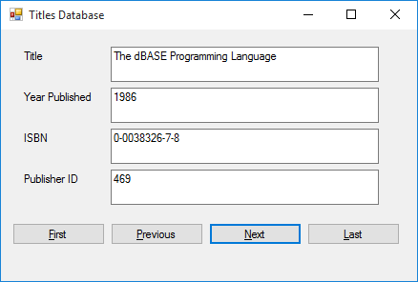
Here’s the last record:

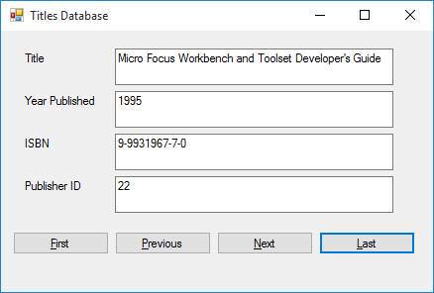

There’s one last thing. If you load this example from the code accompanying the course, you may need to modify the line of code constructing the booksConnection object. The modification is needed if your working copy of the books database (either the Access version, BooksDB.accdb, or the SQL Server version, SQLBooksDB.mdf) is not in the same directory indicated in code. In fact, you will have to do this anytime you use the examples provided with the course.
Data Wizards

When learning new material, many times you are taught the “hard way” to do something before learning the “easy way.” We’re going to show you an easier way to build the application we just built by using Visual C#’s data wizards. Wizards are just that – tools that make your life easier. You will see Example 3-1 can be rebuilt without writing a single line of code!

Even though wizards are easy to use, they have their drawbacks. That’s why you haven’t seen wizards yet – we will always use the “hard way” (data objects) to connect to databases. Wizards provide quick results, but their results are many times inflexible. For databases, the big drawback is that connection information is hard-coded into your programs, making distribution to others very difficult.

Look through Example 3-2 if you like. It steps you through use of data wizards to rebuild Example 3-1. You’ll see that wizards are pretty cool! I still use them for quickly building applications for personal use. And they’re great for quick testing of database application concepts. You decide if you like them or not. As mentioned, they will not be used in this course.

Example 3-2 (Access Database)

Books Database with Wizards

We will rebuild Example 3-1 using data wizards – an application where we can look at a few fields in the Titles table of the books database (BooksDB.accdb).

- Start a new application with just a form. Set the following properties:

Form1:
Name frmTitles
FormBorderStyle FixedSingle
StartPosition CenterScreen
Text Titles Database

The form should look something like this:

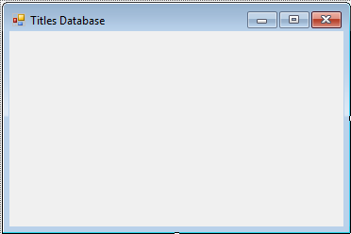

- We now connect to the database. There are many steps. Select the Project menu option and choose Add New Data Source. This window will appear:

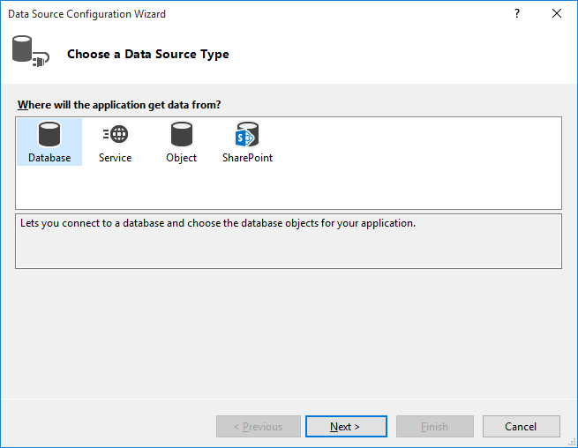

Choose the Database icon and click Next. You will see a screen asking what database model you want to use. Choose Dataset and click Next.

You next specify where the database is located:

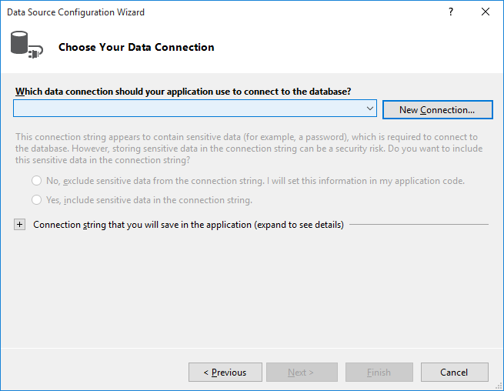

There may or may not be a connection listed in the drop down box. Here is where we will form a needed Connection string to connect to the database. Click New Connection.
In the next screen, you will see:

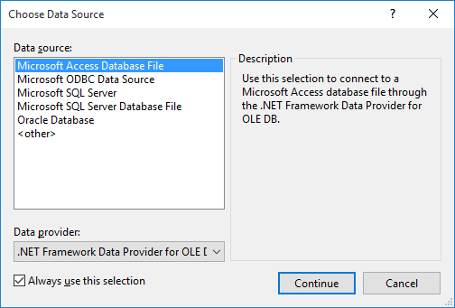

As shown, choose Microsoft Access Database File. This is the proper choice for a Microsoft Access database. Click Continue.

You are shown to the Add Connection window:

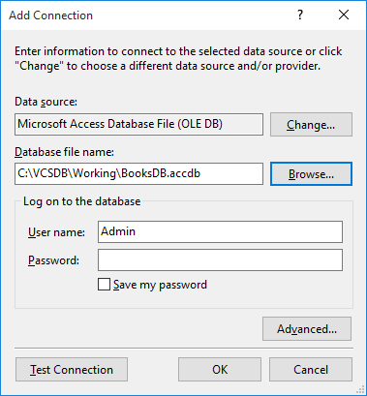

Click the Browse button and point to the BooksDB.accdb database in your working folder – here it is VCSDB\Working ). Once selected, click Test Connection to insure a proper connection.
Once the connection is verified, click OK and you will be returned to the Data Source Configuration Wizard main screen. Click Next and you may be asked if you want to copy the database to your project:

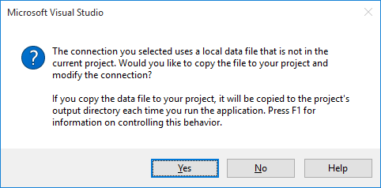

For our example, answer No.
The next screen shows:

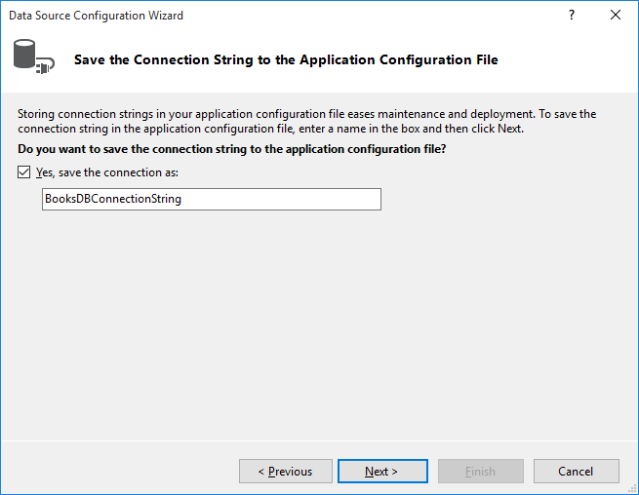

The connection string specifies what database fields are used to form the dataset. Choose the default connection string and click Next. The database connection is finally complete.
- We now need to specify the DataSet or table of data we want to generate. We want to choose the Title, Year_Published, ISBN and PubID fields in the Titles table. Expand the Tables object, then choose the Titles table and place checks next to the desired fields:

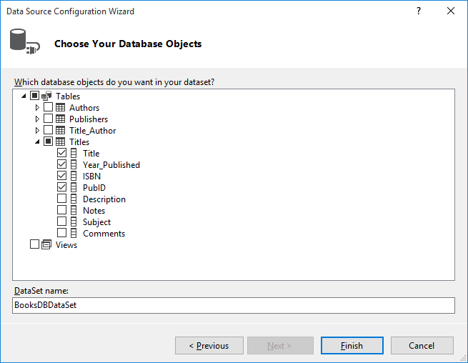

Once these selections are done, click Finish to complete specification of the DataSet.

- Choose the View menu option, then Other Windows and click Data Sources. Pin this window to the IDE. Look in the Data Sources window in your project and you should see the newly created DataSet object (booksDataSet). The dataset contains one table (Titles):

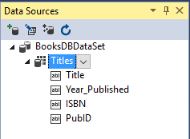

To form this DataTable, Visual C# ‘queried’ the database (generating its own SQL statement) to pull the Title, Year_Published, ISBN and PubID fields out of the database.

- Here’s where the magic begins. Click the Title field in the Data Sources window, then drag and drop it onto the form. You will see:

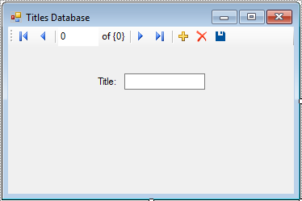

The wizard has created a label and a data bound text box for the Title field. It has also added a navigation tool at the top (you should recognize buttons to move to the first, previous, next and last records, respectively). Below the form are:

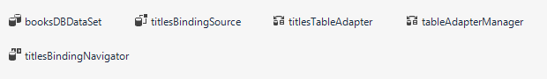

We recognize the booksDataSet object. The titlesTableAdapter object is a DataAdapter that controls communication between the books database and the dataset. The titlesBindingSource and titlesBindingNavigator controls navigation through the dataset. The wizard has essentially done all the steps of doing a connection, establishing a command object, creating a data adapter, a data table and a navigation object. These are all steps we did with code in Example 3-1.

- Drag and drop the three other fields (Year_Published, ISBN, PubID) from the data source window onto the form. Resize things until it resembles this:

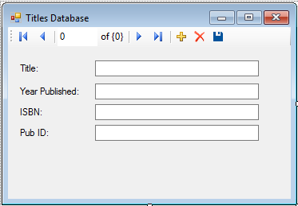

- Save the application (saved in the Example 3-2 folder in VCSDB\Code\Class 3 folder). Run the application. Try out the navigation buttons. Notice how all the fields update with each click of a button. Here’s the first record:

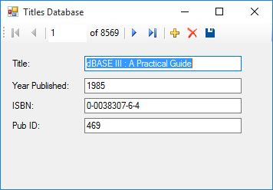
Here’s the last record:

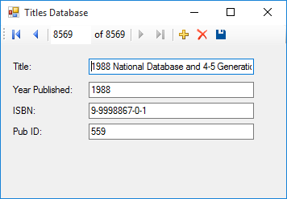

There’s lots of power with this data wizard. A tool to view the Titles table was built without writing a line of code. The power of the wizard is its downfall, however. If you don’t like the appearance of the navigation tool, you can’t use the wizard. All of the information used to build the database connection and other objects is hard-coded into the application. So, if the BooksDB.accdb database is not in the specific folder designated when building the connection, the application will not work.

You decide where data wizards fit within your arsenal of database programming tools. I use them for quick personal applications and to test various database management tasks.
Example 3-2 (SQL Server Database)

Books Database with Wizards

We will rebuild Example 3-1 using data wizards – an application where we can look at a few fields in the Titles table of the books database (BooksDB.accdb).

- Start a new application with just a form. Set the following properties:

Form1:
Name frmTitles
FormBorderStyle FixedSingle
StartPosition CenterScreen
Text Titles Database

The form should look something like this:

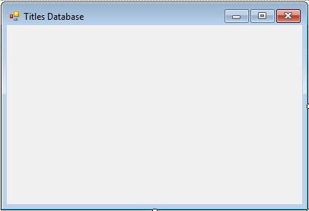

- We now connect to the database. There are many steps. Select the Data menu option and choose Add New Data Source. This window will appear:

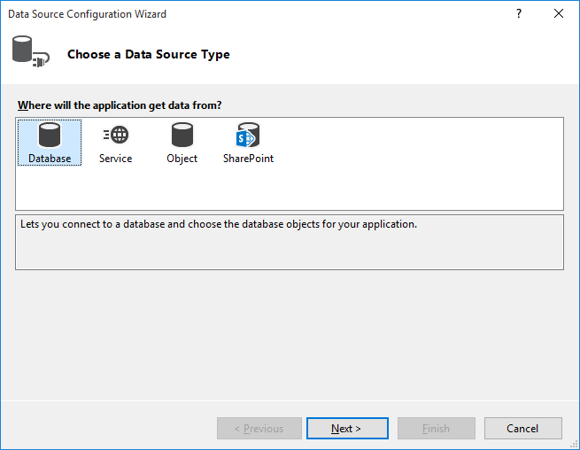

Choose the Database icon and click Next. You will see a screen asking what database model you want to use. Choose Dataset and click Next.

You next specify where the database is located:

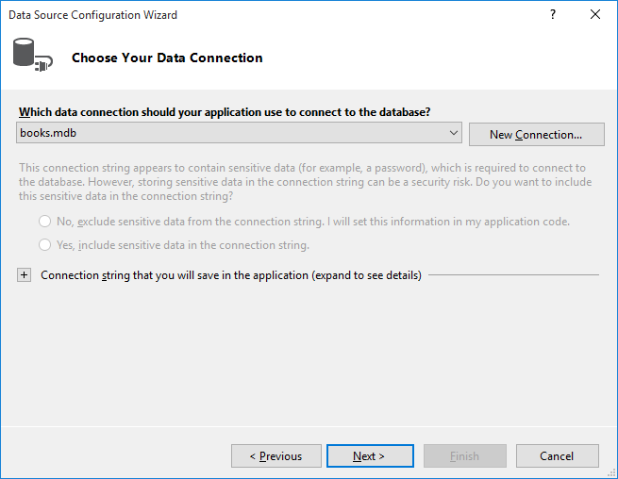

There may or may not be a connection listed in the drop down box. Here is where we will form a needed Connection string to connect to the database. Click New Connection.

In the next screen, you will see:

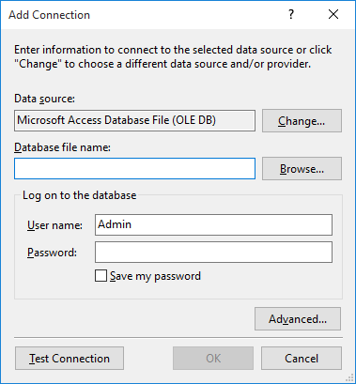

Make sure the Data source shows Microsoft SQL Server. If not, click Change to see:

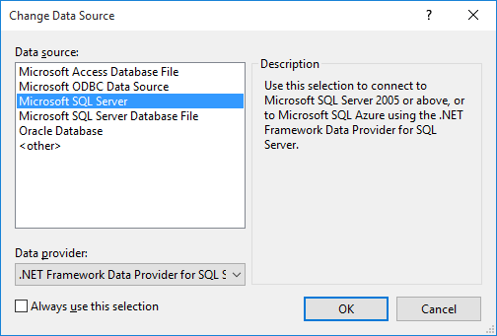

As shown, choose Microsoft SQL Server. Click OK.

You will return to the Add Connection window:

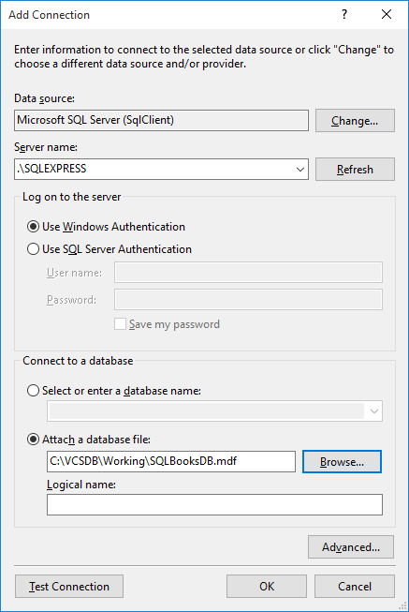

Type your SQL Server name in Server Name. Choose Attach a database file and click the Browse button and point to the SQLBooksDB.mdf database in your working folder – here it is VCSDB\Working ).
Click the Advanced button to see:

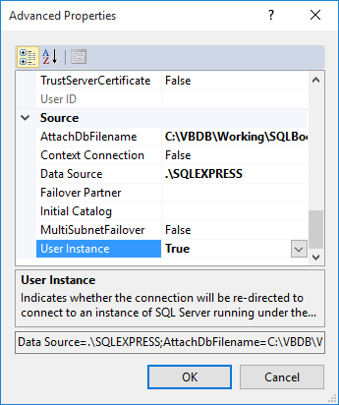

As shown, change the User Instance property to True (needed because SQL Server is on your account). Click OK to return to the Add Connection window. Click Test Connection to insure a proper connection.

Once the connection is verified, click OK and you will be returned to the Data Source Configuration Wizard main screen. Click Next and you may be asked if you want to copy the database to your project:

For our example, answer No.

The next screen shows:

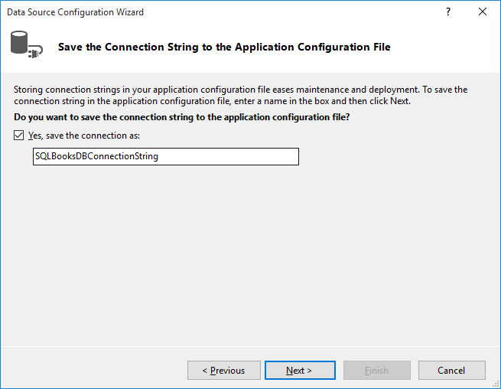

The connection string specifies what database fields are used to form the dataset. Choose the default connection string and click Next. The database connection is finally complete.

- We now need to specify the DataSet or table of data we want to generate. We want to choose the Title, Year_Published, ISBN and PubID fields in the Titles table. Expand the Tables object, then choose the Titles table and place checks next to the desired fields:

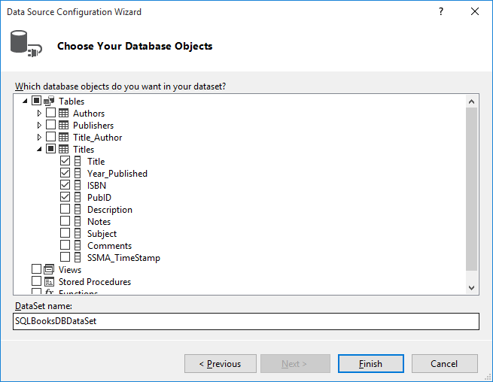

Once these selections are done, click Finish to complete specification of the DataSet.

- Choose the View menu option, then Other Windows and click Data Sources. Pin this window to the IDE. Look in the Data Sources window in your project and you should see the newly created DataSet object (booksDataSet). The dataset contains one table (Titles):

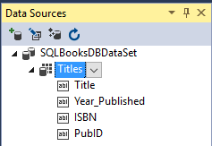

To form this DataTable, Visual C# ‘queried’ the database (generating its own SQL statement) to pull the Title, Year_Published, ISBN and PubID fields out of the database.

- Here’s where the magic begins. Click the Title field in the Data Sources window, then drag and drop it onto the form. You will see:

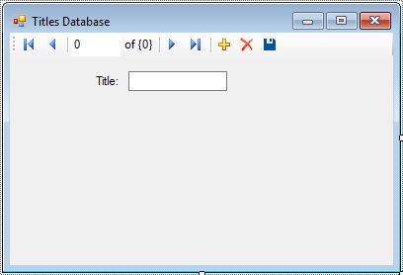

The wizard has created a label and a data bound text box for the Title field. It has also added a navigation tool at the top (you should recognize buttons to move to the first, previous, next and last records, respectively). Below the form are:

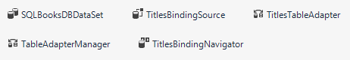

We recognize the SQLBooksDataSet object. The TitlesTableAdapter object is a DataAdapter that controls communication between the books database and the dataset. The TitlesBindingSource and TitlesBindingNavigator controls navigation through the dataset. The wizard has essentially done all the steps of doing a connection, establishing a command object, creating a data adapter, a data table and a navigation object. These are all steps we did with code in Example 3-1.

- Drag and drop the three other fields (Year_Published, ISBN, PubID) from the data source window onto the form. Resize things until it resembles this:

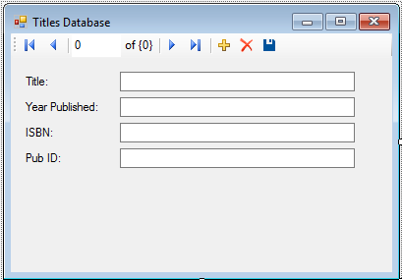

- Save the application (saved in the Example 3-2 SQL folder in VCSDB\Code\Class 3 folder). Run the application. Try out the navigation buttons. Notice how all the fields update with each click of a button. Here’s the first record:

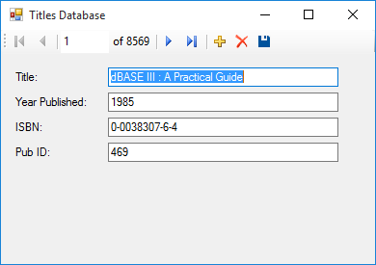
Here’s the last record:

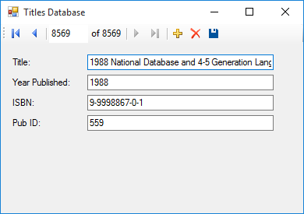

There’s lots of power with this data wizard. A tool to view the Titles table was built without writing a line of code. The power of the wizard is its downfall, however. If you don’t like the appearance of the navigation tool, you can’t use the wizard. All of the information used to build the database connection and other objects is hard-coded into the application. So, if the SQLBooksDB.mdf database is not in the specific folder designated when building the connection, the application will not work.

You decide where data wizards fit within your arsenal of database programming tools. I use them for quick personal applications and to test various database management tasks.
Using SQL Server Databases in Examples

In the two examples in this chapter, we built one for Access databases and one for SQL Server databases. I think you’ll agree there is not a lot of difference in building each type of application.

In future chapters and in Example 3-3, we will provide detailed steps to build Access versions of each example and give you the few steps needed to adapt the example to a SQL Server database. Look for areas titled Using SQL Server Databases at the end of each example.

Summary

In this chapter, we finally used Visual C# to connect to an actual database (both Access and SQL Server versions). We used several ADO .NET data objects to connect to and view the Titles table of the books database using data bound controls.

The objects used were:

Connection Object Forms connection to the database.
Command Object Forms SQL query to retrieve data table from database.
Data Adapter Object Uses command object to transfer data between database and data table.
Data Table Object Holds the table of data retrieved by the data adapter object.
Data Bound Controls Controls ‘bound’ to fields of the data table object.
Currency Manager Object Manages the controls bound to the data table. Provides both navigation and editing capabilities.

We looked at the Visual C# data wizard. The wizard is good for quick prototyping of database applications, but its inflexibility for distribution purposes makes it unsuitable for our work here.

Even after all the work we’ve done, all we can do right now is view database tables, which in some applications is sufficient (think of your local library – they certainly don’t want patrons changing information in their database). To build a complete database management system, we need to know SQL, the powerful language behind database queries. This is discussed in the next chapter.

If you’re feeling overwhelmed by all the material presented thus far, don’t worry – you’ll see it many more times as you continue through this course and become a more proficient database programmer.

Example 3-3

Northwind Traders Database

A second sample database is included with these notes. The Access version is NWIND.MDB, located in the VCSDB\Databases folder. This database is used by a fictional company (Northwind Traders) It has eight tables. In this exercise, we repeat the tasks of Example 3-1, using one table (Customers) in this database. The SQL statement (used in the command object) to do this is:

Select * from Customers

This example gives you further practice in using the ADO .NET data objects and data bound controls and allows you to study the structure of another database.

- Copy NWIND.MDB to your working directory and start a new application. We’ll develop a form where we can look through the Customers table in the Northwind Traders database. Place four label, four text boxes, and four buttons on the form.

- Set the following properties for each control. For the data control and the four text boxes, make sure you set the properties in the order given.

Form1:
Name frmCustomers
FormBorderStyle FixedSingle
StartPosition CenterScreen
Text Customers Database

Label1:
Text Customer ID

Label2:
Text Company Name

Label3:
Text Contact Name

Label4:
Text Contact Title
TextBox1:
Name txtCustomerID
BackColor White
ReadOnly True
MultiLine True

TextBox2:
Name txtCompanyName
BackColor White
ReadOnly True
MultiLine True

TextBox3:
Name txtContactName
BackColor White
ReadOnly True
MultiLine True

TextBox4:
Name txtContactTitle
BackColor White
ReadOnly True
MultiLine True

Button1:
Name btnFirst
Text &First

Button2:
Name btnPrevious
Text &Previous

Button3:
Name btnNext
Text &Next

Button4:
Name btnLast
Text &Last
When done, the form will look something like this:

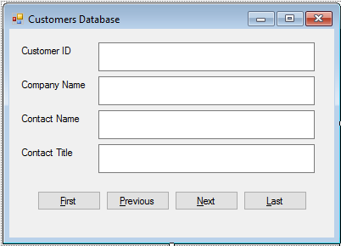

- Add this line at the top of the code window:

using System.Data.OleDb;

- Form level declarations to create data objects:

OleDbConnection NWindConnection;
OleDbCommand customersCommand;
OleDbDataAdapter customersAdapter;
DataTable customersTable;
CurrencyManager customersManager;

- Add this code the frmCustomers_Load method:

private void frmCustomers_Load(object sender, EventArgs e)
{
// connect to NWind database
NWindConnection = new OleDbConnection("Provider=Microsoft.ACE.OLEDB.12.0; Data Source = c:\\VCSDB\\Working\\NWindDB.accdb");
//open the connection
NWindConnection.Open();
// establish command object
customersCommand = new OleDbCommand("SELECT * FROM Customers", NWindConnection);
// establish data adapter/data table
customersAdapter = new OleDbDataAdapter();
customersAdapter.SelectCommand = customersCommand;
customersTable = new DataTable();
customersAdapter.Fill(customersTable);
// bind controls to data table
txtCustomerID.DataBindings.Add("Text", customersTable, "CustomerID");
txtCompanyName.DataBindings.Add("Text", customersTable, "CompanyName");
txtContactName.DataBindings.Add("Text", customersTable, "ContactName");
txtContactTitle.DataBindings.Add("Text",customersTable, "ContactTitle");
// establish currency manager
customersManager = (CurrencyManager) BindingContext[customersTable];
//close the connection
NWindConnection.Close();
//dispose of the connection object
NWindConnection.Dispose();
customersCommand.Dispose();
customersAdapter.Dispose();
customersTable.Dispose();
}
- Code for the four button Click events to allow navigation:

private void btnFirst_Click(object sender, EventArgs e)
{
customersManager.Position = 0;
}

private void btnPrevious_Click(object sender, EventArgs e)
{
customersManager.Position--;
}

private void btnNext_Click(object sender, EventArgs e)
{
customersManager.Position++;
}

private void btnLast_Click(object sender, EventArgs e)
{
customersManager.Position = customersManager.Count - 1;
}

- Save the application (saved in the Example 3-3 folder in VCSDB\Code\Class 3 folder). Run the application. Cycle through the various customers using the navigation buttons. Here’s the last record:

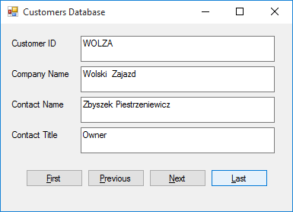
Example 3-3

Using SQL Server Databases

Differences in the SQL Server version of the example:

- The SQL Server version of the Northwind Traders database (SQLNWindDB.mdf) can be downloaded from our web site, as explained in Chapter 2, or if you have a CD-ROM of these notes, it is also in the VCSDB\Databases folder. Copy SQLNWindDB.mdf to your working directory

- Use this using statement:

using System.Data.SqlClient;

- Use these statements to declare the data objects:

SqlConnection NWindConnection;
SqlCommand customersCommand;
SqlDataAdapter customersAdapter;

- In frmCustomers Load method, use this connection object:

NWindConnection = new SqlConnection("Data Source=.\\SQLEXPRESS; AttachDbFilename=c:\\VCSDB\\Working\\SQLNWindDB.mdf; Integrated Security=True; Connect Timeout=30; User Instance=True");

- In frmCustomers Load method:

Change all instances of OleDbCommand to SqlCommand
Change all instances of OleDbDataAdapter to SqlDataAdapter

The SQL Server version is saved in the Example 3-3 SQL folder in VCSDB\Code\Class 3 folder.

